Project
  - Deadline: Monday 09/08/2026 @ 23:59
[Total Mark is 20]

Introduction to Database
CS350
Instructions:
- You must submit two separate copies (one Word file and one PDF file) using the Assignment Template on Blackboard via the allocated folder. These files must not be in compressed format.
- It is your responsibility to check and make sure that you have uploaded both the correct files.
- Zero mark will be given if you try to bypass the SafeAssign (e.g. misspell words, remove spaces between words, hide characters, use different character sets, convert text into image or languages other than English or any kind of manipulation).
- Email submission will not be accepted.
- You are advised to make your work clear and well-presented. This includes filling your information on the cover page.
- You must use this template, failing which will result in zero mark.
- You MUST show all your work, and text must not be converted into an image, unless specified otherwise by the question.
- Late submission will result in ZERO mark.
- The work should be your own, copying from students or other resources will result in ZERO mark.
- Use Times New Roman font for all your answers.
Student Details: CRN:
Name: Ghazal wakil  Name: Anhar alsafour  Name: Mona alsulami  Name: Nahlah alragas |  | ID: 240033970  ID: 240014320  ID: 230051429  ID: 240005860

Project Instructions
- You can work on this project as a group (minimum 3 and maximum 4 students). Each group member must submit the project individually with all group member names mentioned on the cover page.
- This project worth 20 marks and will be distributed as in the following:
  - Database Design. (6 marks)
  - Database Implementation. (6 marks)
  - SQL Operations. (6 marks)
  - Project Reflection. (2 marks)
- Each leader in the group must submit one report about their chosen Project via the Blackboard (Email submission will not be accepted and will be awarded ZERO marks) containing the following:
- Task 1 : database design
- Task 2: database implementation
- All requested queries/results
- Screenshots from MySQL (or any other software you use) of all the tables after population and query results.
- Reflection (300–500 words) describing the team's experience, challenges, design decisions, and AI usage (if applicable).
- Submit one SQL file containing the complete database implementation, including database creation, tables, data insertion, required queries, VIEW, and TRIGGER.
- Submit a GitHub (or GitLab) repository containing the complete project with regular commits and meaningful commit messages.
- Submit a progress report describing the completed work, key decisions, challenges, future plan, and contribution of each group member.
- Include links to the live report document, GitHub/GitLab repository, and Google Colab notebook (if applicable) in the Project Artifacts section of the final report.
- You are advised to make your work clear and well presented; marks may be reduced for poor presentation. This includes filling in your information on the cover page.
- You MUST show all your work, and text must not be converted into an image unless specified otherwise by the question.
- Late submission will result in ZERO marks being awarded.
- The work should be your own. Copying from students or other resources, including AI software, will result in ZERO marks.

Project Description
Design and Implementation of a Smart Clinic Database System
Learning Outcome(s):

CLO1, CLO2, CLO3, CLO4, CLO5

A private clinic currently manages its patient information manually, making it difficult to organize appointments, treatments, and payments. The clinic has decided to develop a database system to improve data organization and retrieval.
Your team is required to design, implement, and test a complete relational database using the concepts learned throughout this course. The project should demonstrate your understanding of database design, ER/EER modeling, relational mapping, SQL implementation, and advanced SQL queries. The project must be completed using MySQL.

Mid-project progress report
Is in the last page

Task 1 – Database Design (6 Marks)
- Design a complete database for the clinic that includes at least six entities such as Patients, Doctors, Appointments, Treatments, Medicines, Payments, or any other appropriate entities.
- A complete ER/EER diagram.
- Primary and foreign keys.
- Appropriate relationships with cardinality.
- At least one specialization/generalization (EER feature).
- Any assumptions made during the design process.

Next page

The assumptions
Let's assume a single patient has multiple appointments. For example, a patient might have an appointment with an ophthalmologist and another with a neurologist. The relationship here is 1-N

We also assume the relationship between a doctor and an appointment is 1-N, since a doctor usually sees only one patient at a time, but a doctor can have multiple appointments.
Let's assume the relationship between an appointment and payment is that an appointment can be free (0) or require a payment (1). Therefore, the relationship between them is 1- 0..1

The relationship between the appointment provider and the treatment provider, if we assume that a single appointment provider offers multiple treatments, is one, because a patient might be diagnosed with several conditions requiring multiple treatments during an appointment. The relationship here is 1-N

If we assume that a single treatment uses multiple medications that a single medication can be used for multiple treatments, the relationship between treatment and medication is N-M

The relationship between a clinic provider and a doctor provider is 1-N , if we assume that a clinic employs multiple doctors, but each doctor works at only one clinic.

We assume a 1-N relationship between the clinic and the room, since a single clinic contains several rooms.

Finally, we assumed that the doctor could be either a general practitioner or a specialist.

EER diagram
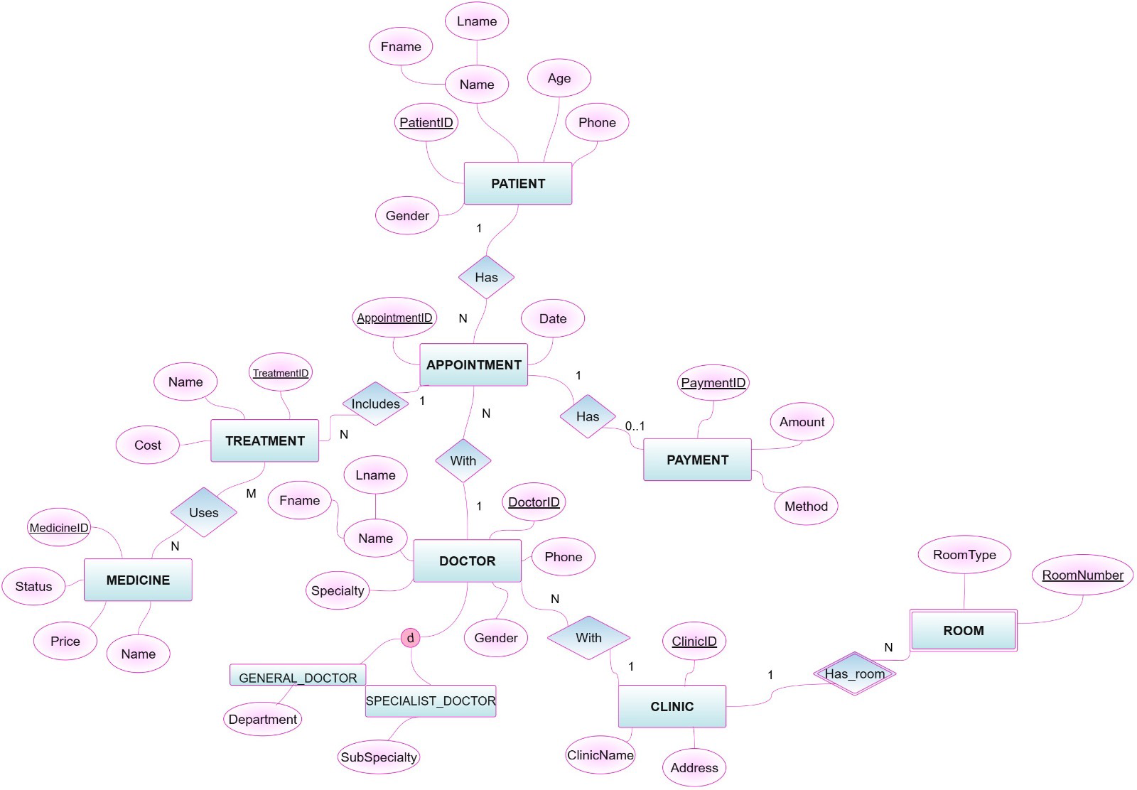

Task 2 – Database Implementation (6 Marks)
Complete the following tasks using MySQL. Include screenshots of both your SQL code and the corresponding output (results) for each task:
- Create the database and all required tables.
- Use appropriate data types and constraints (PRIMARY KEY, FOREIGN KEY, NOT NULL, UNIQUE, etc.).
- Insert at least 5 records into each main table.

Task 3 – SQL Operations (6 Marks)
Complete the following tasks using MySQL. For each task, include screenshots of both your SQL code and the corresponding output (results), along with a brief description (one to two sentences) explaining the purpose of the query and the information it is intended to retrieve.
- Write SELECT statements.
- Write JOIN queries.
- Write nested queries.
- Use aggregate functions with GROUP BY.
- Write UPDATE and DELETE statements.
- Create one VIEW.
- Create one TRIGGER.

Task 4 – Reflection (2 Marks)
Write a 300–500-word reflection on your experience while completing this project by
answering the following questions. Your responses should be clear, concise, and
supported with specific examples from your own work.
- Describe one specific challenge or obstacle you encountered during this project and explain in detail how you identified and resolved it.
- Explain why you chose your specific approach/method/model over at least one alternative you considered, and what tradeoffs informed that decision.
- If you used any AI tools during this project (e.g., ChatGPT, Claude, Copilot), disclose which tool(s), for what specific purpose (e.g., debugging, grammar checking, brainstorming), and how you verified or modified the output.
- What would you do differently if you were to redo this project with more time or resources?

Deliverables
- Project Report (PDF) – System description, ER/EER diagram, relational schema, SQL code, screenshots, and reflection.
- SQL Script (.sql) – Complete SQL implementation of the project.
- GitHub Repository – Repository link with the complete project and commit history.

- Project Artifacts

  - Live report document (with edit history): [link]
  - GitHub/GitLab repository (with commit history): [link]
  - Google Colab notebook (if applicable): [link]

- Mid-Project Progress Report – Summary of progress, challenges, decisions, and team contributions.

Mid-Project Progress Report

Summary of Progress

1. Ghazal wakil - has successfully completed Task 1 (Database Design)
including identifying the entities, defining the attributes, primary keys, foreign keys, relationships, cardinalities, and creating both the ER and EER diagrams
The design assumptions were also completed and added to the project document.

2. Anhar alsafour - is currently working on Task 2 (Database Implementation)
The database and table creation process is in progress and the implementation is moving forward after resolving the coding issues encountered during development.

3. Mona alsuami - has collaborated with the team by reviewing the project structure and helping organise the implementation plan
Since the project tasks are closely connected Mona is waiting for Task 2 to be completed before starting the SQL Operations in Task 3.

4. Nahlah alragas- started preparing the project documentation
including the Mid-Project Progress Report, while also organising the project files and ensuring that the documentation follows the required format.

Challenges

- One of the main challenges during the database design phase was selecting the appropriate attributes for each entity and ensuring that the relationships and cardinalities between the entities were correctly identified.

- Another challenge was choosing a suitable platform for designing the EER diagram After evaluating different options the team selected draw as it provided the required features for creating and organising the database model.

- During the database implementation phase some SQL coding issues were encountered After reviewing and debugging the code these issues were successfully resolved allowing the team to continue with Task 2.

Future Plan

1. Anhar alasafour will complete the remaining Database Implementation tasks including inserting sample data into the tables and verifying that all constraints function correctly.
2. Once Task 2 is completed Mona Alsulami will begin Task 3 (SQL Operations Part 1) by developing the required SELECT statements JOIN queries nested queries and aggregate functions.
3. Nahlah alragas will continue preparing the project documentation organising screenshots and compiling the final report while supporting the team in completing the remaining project requirements.

The Team Contributions

1.[Ghazal wakil / 240033970]: Successfully completed Task 1 (Database Design)
by identifying the entities, defining attributes, primary and foreign keys, relationships, cardinalities, creating the ER and EER diagrams, writing the design assumptions and adding all completed work to the project document.

2. [Anhar alasafour / 240014320]: Responsible for Task 2 (Database Implementation)
Resolved the coding challenges encountered during implementation and is continuing the development of the database, tables, constraints and data insertion.

3. [mona alsulami / 230051429]: Assisted the team in reviewing and organising the project workflow. Prepared to begin Task 3 (SQL Operations – Part 1) once the database implementation is completed.

4. [nahlah alragas/ 240005860]: Responsible for preparing the Mid-Project Progress Report, organising the project documentation, maintaining the overall structure of the project files, and supporting the team with the required documentation tasks.

